SIMATS ENGINEERING

ASSESSMENT TOOL 2

COURSE CODE: ITA0601 COURSE NAME: MACHINE LEARNING

COURSE OUTCOME COVERED

CO3: Bayes Theorem – Concept Learning – Maximum Likelihood – Minimum Description Length Principle – Bayes Optimal Classifier – Gibbs Algorithm – Naïve Bayes Classifier – Bayesian Belief Network – EM Algorithm – Probability Learning – Sample Complexity – Finite and Infinite Hypothesis Spaces – Mistake Bound Model, (BL 6)
Assessment Tool Weightage: 20%

QUESTIONS: 15 Total Marks:25
Annexure A

Case Study

Code of Conduct:
I S.Sri Sai Prasanna Durga (192424241) (Name / Reg No) certify that this submission is my original work and that I have adhered to the guidelines specified for this assessment.
I understand that any violation of academic integrity rules will result in disciplinary action.

Signature of the student:

S. Sai Prasanna
Annexure A

Short Answer Test
1, A hospital aims to develop an intelligent system to diagnose diseases based on patient symptoms and medical history. Using concepts such as Bayes’ Theorem, Naïve Bayes classifiers, and Bayesian Belief Networks, design a probabilistic model for diagnosis. Analyze how uncertainty is handled and how conditional dependencies between symptoms influence predictions. Discuss the role of probability learning and evaluate the effectiveness of your approach with respect to real-world constraints.

- An organization wants to build a spam detection system for emails using machine learning techniques. Using Naïve Bayes and Bayes Optimal Classifier concepts, design a classification system. Compare Maximum Likelihood estimation with Minimum Description Length (MDL) principle in feature selection. Analyze system performance, discuss trade-offs in model complexity, and evaluate how sample size and hypothesis space affect classification accuracy.

- A telecommunications company aims to predict customer churn using historical usage data and service feedback. Using probabilistic models such as Naïve Bayes, Bayesian inference, and hypothesis space search, design a predictive system. Analyze how prior probabilities and feature dependencies influence churn prediction. Evaluate how uncertainty in customer behavior is handled and discuss the effectiveness of the model in improving customer retention strategies.

- A smart healthcare system is designed to monitor patients in real-time using wearable sensors. Using Bayesian Belief Networks and probability learning, develop a model to detect anomalies in vital signs. Analyze how conditional dependencies between physiological parameters are modeled and how uncertainty due to sensor noise is handled. Evaluate system performance and discuss challenges in real-time deployment.

- A logistics company wants to optimize delivery routes under uncertain traffic and weather conditions. Using Bayesian inference and probabilistic reasoning, design a system that predicts optimal routes dynamically. Analyze how prior knowledge and real-time data updates influence decision-making. Evaluate computational complexity and discuss how uncertainty impacts route optimization efficiency.

.

CASE STUDY 1: PROBABILISTIC HOSPITAL DISEASE DIAGNOSIS
1. Problem Understanding:
A hospital wants to develop an intelligent disease diagnosis system that can assist doctors in identifying the most probable disease based on a patient's symptoms and medical history. In real-world healthcare, a patient may have several symptoms that are associated with different diseases. Therefore, diagnosis involves uncertainty.
A probabilistic machine learning system can estimate the probability of different diseases using the patient's observed symptoms. Bayes' Theorem, Naïve Bayes Classifier, and Bayesian Belief Networks can be used to develop such a system.
The system does not simply give a yes/no answer. Instead, it calculates the probability of each possible disease and identifies the disease with the highest probability.
2. Objective:
The main objectives of the proposed system are:
- To develop a probabilistic model for disease diagnosis.
- To apply Bayes' Theorem for calculating disease probabilities.
- To use the Naïve Bayes Classifier for efficient disease classification.
- To use a Bayesian Belief Network (BBN) to represent relationships between symptoms and diseases.
- To handle uncertainty in patient symptoms and medical history.
- To learn probabilities from historical patient data.
- To evaluate the effectiveness of the proposed system under real-world healthcare constraints.
3. Concepts Used:
3.1 Bayes' Theorem
Bayes' Theorem is used to calculate the probability of a hypothesis after observing evidence.
The formula is:
P(Disease | Symptoms) = [P(Symptoms | Disease) × P(Disease)] / P(Symptoms)
Where:
- P(Disease | Symptoms) = Probability of the disease given the symptoms.
- P(Symptoms | Disease) = Probability of observing the symptoms when the disease is present.
- P(Disease) = Prior probability of the disease.
- P(Symptoms) = Overall probability of observing the symptoms.
Bayes' Theorem allows the system to update its belief about a disease when new patient information becomes available.
3.2 Naïve Bayes Classifier:
Naïve Bayes is a probabilistic classification algorithm based on Bayes' Theorem.
For example, consider symptoms such as:
- Fever
- Cough
- Fatigue
- Headache
The classifier calculates the probability of different diseases based on these symptoms.
The Naïve Bayes assumption is that the symptoms are conditionally independent given the disease.
For example:
P(Fever, Cough, Fatigue | Flu)
is approximated as:
P(Fever | Flu) × P(Cough | Flu) × P(Fatigue | Flu)
This assumption makes the algorithm simple and computationally efficient.
3.3 Bayesian Belief Network:
A Bayesian Belief Network is a graphical representation of probabilistic relationships between variables.
For the hospital system, the network can represent relationships such as:
Disease → Fever
Disease → Cough
Disease → Fatigue
Disease → Headache
More detailed dependencies can also be represented:
Respiratory Infection → Cough → Breathing Difficulty
This allows the system to represent relationships between symptoms rather than assuming that every symptom is completely independent.
4. Proposed System:
The proposed hospital diagnosis system consists of the following stages:
Patient Data
↓
Symptoms + Medical History
↓
Data Preprocessing
↓
Probability Learning
↓
Bayes' Theorem / Naïve Bayes / Bayesian Belief Network
↓
Disease Probability Calculation
↓
Disease Ranking
↓
Most Probable Diagnosis
↓
Doctor's Final Decision
The system acts as a decision-support system. The final medical decision should remain with a qualified healthcare professional.
5.Architecture Diagram:
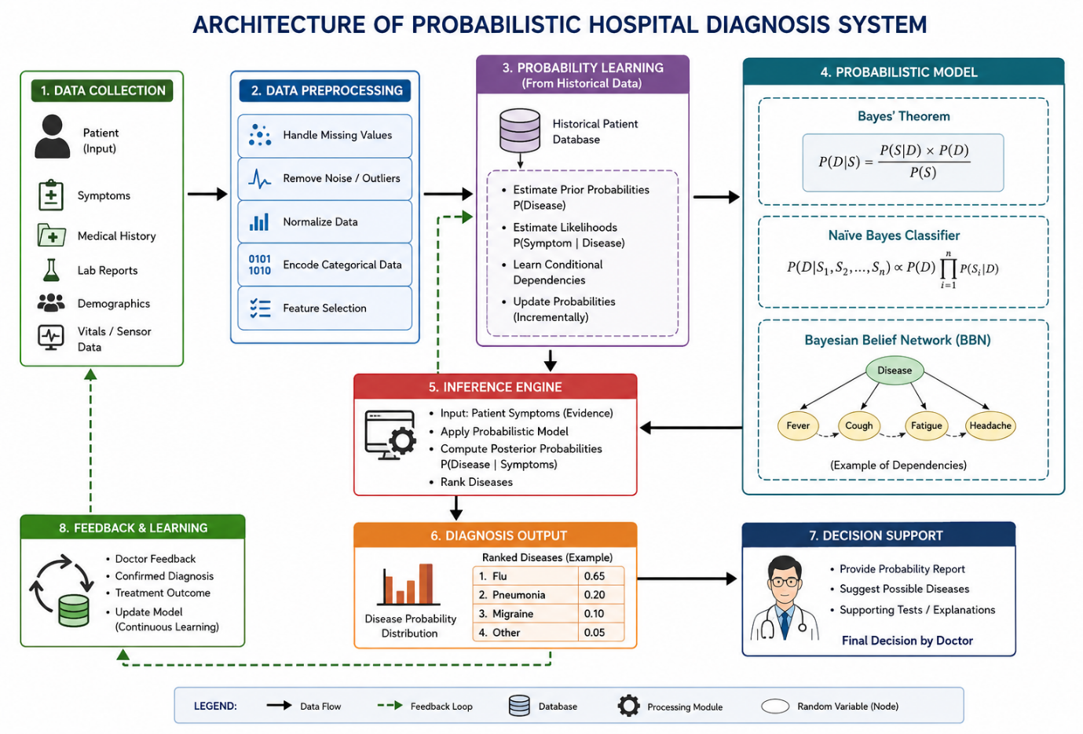
6. Working Methodology:
Step 1: Collect Patient Information
The system receives information such as:
- Age
- Gender
- Previous medical history
- Fever
- Cough
- Headache
- Fatigue
- Blood pressure
- Temperature
- Other relevant clinical observations
Step 2: Preprocess the Data
The collected data is checked for:
- Missing values
- Incorrect values
- Duplicate records
- Sensor errors
- Inconsistent data
The data is then converted into a suitable format for probability calculation.
Step 3: Learn Probabilities
Historical patient records are used to estimate probabilities.
For example, the system may learn:
- Probability of a disease in the population.
- Probability of fever when a disease is present.
- Probability of cough when a disease is present.
- Probability of fatigue when a disease is present.
Step 4: Apply Bayes' Theorem
When a new patient arrives, the system uses the patient's symptoms as evidence.
It calculates the posterior probability of each possible disease.
Step 5: Compare Disease Probabilities
The probabilities of different diseases are compared.
For example:
Disease | Calculated Probability
Flu | 0.65
Pneumonia | 0.20
Migraine | 0.10
Other | 0.05
The system identifies Flu as the most probable condition in this illustrative example.
Step 6: Generate Decision Support
The system provides the probability ranking to the doctor.
The doctor can combine this information with:
- Physical examination
- Laboratory tests
- Medical history
- Clinical experience
to make the final diagnosis.
7. Illustrative Bayes' Theorem Calculation:
Consider a simplified example.
Suppose:
- P(Flu) = 0.30
- P(Fever | Flu) = 0.80
- P(Fever) = 0.50
Using Bayes' Theorem:
P(Flu | Fever) = [P(Fever | Flu) × P(Flu)] / P(Fever)
Substituting the values:
P(Flu | Fever) = (0.80 × 0.30) / 0.50
P(Flu | Fever) = 0.48
Therefore:
P(Flu | Fever) = 48%
This demonstrates how the system updates the probability of a disease after observing a symptom.
This is only an illustrative calculation; actual clinical probabilities must be learned from appropriate medical datasets.
8. Handling Uncertainty:
Uncertainty is an important characteristic of medical diagnosis.
A patient may have symptoms that are common to multiple diseases. For example, fever can occur in flu, infections, and several other conditions.
The probabilistic model handles this uncertainty by assigning probabilities instead of making an absolute decision.
For example:
Disease | Probability
Flu | 48%
Pneumonia | 30%
Other infection | 22%
Instead of saying that the patient definitely has flu, the system indicates that flu has the highest estimated probability among the considered alternatives.
This makes probabilistic reasoning useful for decision support.
9. Conditional Dependencies Between Symptoms:
One limitation of the basic Naïve Bayes model is its assumption that symptoms are conditionally independent given the disease.
However, in real healthcare systems, symptoms can be related.
For example:
Respiratory Infection
↓
Cough
↓
Breathing Difficulty
Another relationship may be:
Infection
↓
Fever
↓
Increased Heart Rate
A Bayesian Belief Network can represent these dependencies.
This can make the model more expressive when relationships between medical variables are important.

10. Role of Probability Learning:
Probability learning allows the system to learn from historical patient records.
Suppose the hospital has thousands of previous cases containing:
- Symptoms
- Diagnoses
- Test results
- Patient history
- Treatment outcomes
The system can use these records to estimate probabilities.
For example:
P(Fever | Flu)
represents how frequently fever occurs among patients diagnosed with flu.
As more reliable data becomes available, the estimated probabilities can be updated.
Therefore, probability learning allows the system to improve its estimates based on accumulated evidence.
11. Performance Evaluation:
The effectiveness of the disease diagnosis system can be evaluated using standard classification measures.
Accuracy
Accuracy measures the proportion of correctly classified cases.
Accuracy = Correct Predictions / Total Predictions
Precision
Precision measures how many cases predicted as a particular disease are actually that disease.
Precision = TP / (TP + FP)
Recall
Recall measures how many actual cases of a disease were correctly identified.
Recall = TP / (TP + FN)
F1-Score
F1-score combines precision and recall.
F1 = 2 × (Precision × Recall) / (Precision + Recall)
In healthcare, recall can be especially important for detecting serious diseases because missing an actual case can have significant consequences.
12. Advantages:
The proposed probabilistic diagnosis system provides several advantages:
- It can handle uncertain information.
- It can combine multiple symptoms.
- Naïve Bayes is computationally efficient.
- Bayesian Belief Networks can represent dependencies between variables.
- Historical data can be used for probability learning.
- The system can provide probability-based predictions.
- It can support doctors in making informed decisions.
- It can be updated when new evidence becomes available.
13. Limitations and Real-World Constraints:
Although the proposed system is useful, several challenges must be considered.
1. Incomplete Data
Some patients may have missing medical history or incomplete test results.
2. Incorrect Data
Incorrectly entered patient information can affect the prediction.
3. Sensor and Measurement Errors
Medical devices may produce noisy or inaccurate measurements.
4. Independence Assumption
Naïve Bayes assumes conditional independence of features, which may not always be true in medical applications.
5. Data Bias
If the training data does not represent the actual patient population, predictions may be less reliable.
6. Privacy
Patient medical information must be protected and handled according to applicable privacy and security requirements.
7. False Predictions
A probabilistic model can make incorrect predictions. Therefore, it should support rather than replace qualified clinical judgment.
8. Real-Time Requirements
Healthcare applications may require fast predictions, especially in emergency situations.
14. Overall Analysis:
The combination of Bayes' Theorem, Naïve Bayes, and Bayesian Belief Networks provides a suitable framework for probabilistic disease diagnosis.
Bayes' Theorem provides the mathematical foundation for updating disease probabilities.
Naïve Bayes provides a simple and efficient classification approach.
Bayesian Belief Networks provide a graphical representation of conditional relationships between medical variables.
Probability learning allows the model to estimate its parameters from historical patient data.
The main advantage of the approach is that it explicitly represents uncertainty rather than treating every prediction as completely certain.
15. Conclusion:
A probabilistic hospital disease diagnosis system can use Bayes' Theorem, Naïve Bayes, and Bayesian Belief Networks to estimate the probability of diseases based on symptoms and medical history. Bayes' Theorem allows the system to update disease probabilities when new evidence is observed, while Naïve Bayes provides an efficient classification method. Bayesian Belief Networks can represent conditional dependencies between symptoms and physiological variables.
Probability learning from historical patient records allows the system to estimate relevant probabilities and improve its predictions. However, real-world issues such as incomplete data, sensor noise, privacy, bias, and incorrect predictions must be considered. Therefore, the proposed system is best used as a clinical decision-support tool, with final decisions made by qualified healthcare professionals.
CASE STUDY 2: NAÏVE BAYES-BASED EMAIL SPAM DETECTION
1. Problem Understanding:
An organization receives a large number of emails every day. Some emails are legitimate and useful, while others are unwanted spam messages containing advertisements, fraudulent content, suspicious links, or malicious attachments. Manually identifying spam is time-consuming and difficult.
Therefore, the organization wants to develop an intelligent spam detection system using machine learning. The system should analyze the characteristics of an email and classify it as either Spam or Not Spam (Ham).
A probabilistic approach is suitable because the presence of words and other email features does not always provide a completely certain indication of spam. Naïve Bayes can estimate the probability that an email belongs to each class. The Bayes Optimal Classifier provides a theoretical approach for considering multiple possible hypotheses. Maximum Likelihood Estimation (MLE) and the Minimum Description Length (MDL) principle can be used to understand feature estimation and model selection.
2. Objective:
The main objectives of the proposed spam detection system are:
- To develop a probabilistic email classification system.
- To apply the Naïve Bayes classifier for spam detection.
- To understand the role of the Bayes Optimal Classifier.
- To compare Maximum Likelihood Estimation with the MDL principle.
- To analyze the effect of sample size on classification accuracy.
- To understand the effect of finite and large hypothesis spaces.
- To analyze the trade-off between model complexity and classification performance.
- To evaluate the effectiveness of the proposed system.

3. Concepts Used:
3.1 Naïve Bayes Classifier
Naïve Bayes is a probabilistic classification algorithm based on Bayes' Theorem.
For an email containing features (X_1, X_2, ..., X_n), the probability of a class can be estimated as:
P(Class | Features) ∝ P(Class) × P(Feature₁ | Class) × P(Feature₂ | Class) × ... × P(Featureₙ | Class)
For spam detection, the two classes are:
- Spam
- Not Spam
The classifier calculates the probability for both classes and assigns the email to the class with the higher probability.
3.2 Bayes Optimal Classifier
The Bayes Optimal Classifier considers all possible hypotheses and combines their predictions according to their posterior probabilities.
Conceptually:
Prediction = Most probable decision considering all possible hypotheses
This provides a theoretical benchmark for classification because uncertainty about which hypothesis is correct is taken into account.
In practical spam detection systems, using every possible hypothesis may be computationally expensive. Therefore, Naïve Bayes is often preferred because it provides a simpler and efficient probabilistic solution.
3.3 Maximum Likelihood Estimation
Maximum Likelihood Estimation estimates model parameters by selecting values that make the observed training data most likely.
For spam detection, MLE can be used to estimate quantities such as:
- Probability of a word occurring in spam emails.
- Probability of a word occurring in legitimate emails.
- Probability of an email belonging to the spam class.
For example:
P("free" | Spam)
can be estimated from the training dataset by observing how frequently the word "free" occurs in spam messages.
3.4 Minimum Description Length Principle
The Minimum Description Length (MDL) principle selects a model by considering both:
- The complexity of the model.
- The amount of information required to describe the remaining data errors.
The basic idea is:
Best Model = Model with minimum total description length
The total description length can be viewed conceptually as:
L(Model) + L(Data | Model)
where:
- L(Model) = description length of the model.
- L(Data | Model) = description length of the data that is not explained by the model.
MDL helps prevent unnecessary complexity and can be useful for feature selection.
4. Proposed Spam Detection System:
The proposed system follows these stages:
Email Dataset
↓
Data Preprocessing
↓
Feature Extraction
↓
Probability Learning
↓
Naïve Bayes Classifier
↓
Spam Probability / Not-Spam Probability
↓
Classification
↓
Spam / Not Spam
The system can use features such as:
- Words in the subject
- Words in the email body
- Number of links
- Number of attachments
- Sender information
- Presence of promotional words
- Number of capital letters
- Frequency of suspicious terms
5. Architecture of the Proposed System:
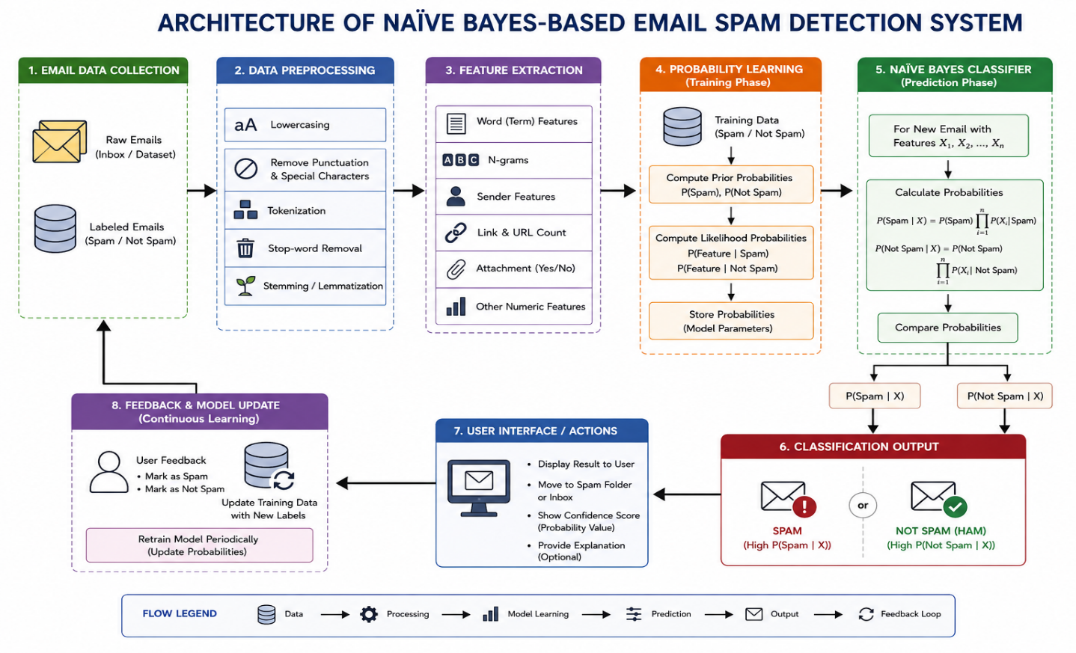
6. Working Methodology:
Step 1: Collect Email Data
A dataset containing previously classified emails is collected.
Each email is labelled as:
- Spam
- Not Spam
For example:
Email | Class
"Win a free prize now" | Spam
"Meeting scheduled for tomorrow" | Not Spam
"Congratulations! You won cash" | Spam
"Project report attached" | Not Spam
Step 2: Preprocess the Emails
Email text may contain unnecessary information. Therefore, preprocessing is performed.
Common preprocessing operations include:
- Converting text to lowercase.
- Removing unnecessary symbols.
- Tokenizing the email into words.
- Removing irrelevant stop words where appropriate.
- Handling URLs and special characters.
- Removing duplicate emails.
Step 3: Extract Features
Important characteristics are extracted from each email.
For example:
Feature | Example
"free" present | Yes
"offer" present | Yes
Suspicious link | Yes
Unknown sender | Yes
Attachment | No
Promotional language | Yes
These features are provided to the probabilistic classifier.
Step 4: Learn Probabilities
The model learns probabilities from the training dataset.
For example:
P(Spam) = probability that an email is spam.
P(Not Spam) = probability that an email is legitimate.
The system can also estimate:
P("free" | Spam)
P("free" | Not Spam)
P("offer" | Spam)
P("offer" | Not Spam)
These probabilities are then used to classify new emails.
7. Illustrative Naïve Bayes Example:
Consider a new email containing the words:
"free offer"
Suppose the trained model has learned the following illustrative values:
Probability | Value
P(Spam) | 0.40
P(Not Spam) | 0.60
P(Free | Spam) | 0.70
P(Offer | Spam) | 0.60
P(Free | Not Spam) | 0.10
P(Offer | Not Spam) | 0.05
For Spam:
Score(Spam) = P(Spam) × P(Free | Spam) × P(Offer | Spam)
= 0.40 × 0.70 × 0.60
= 0.168
For Not Spam:
Score(Not Spam) = P(Not Spam) × P(Free | Not Spam) × P(Offer | Not Spam)
= 0.60 × 0.10 × 0.05
= 0.003
Since:
0.168 > 0.003
the classifier predicts the email as:
SPAM
These values are only an illustrative example. Actual probabilities would be learned from the organization's email dataset.
8. Bayes Optimal Classifier in Spam Detection:
The Bayes Optimal Classifier considers multiple possible hypotheses about how email features are related to spam.
For example, different hypotheses may consider:
- Word frequency.
- Sender characteristics.
- Number of links.
- Email structure.
- Subject-line patterns.
Each hypothesis has a posterior probability based on the training data.
The Bayes Optimal approach combines the predictions of these hypotheses according to their probabilities.
Advantage
It can theoretically provide highly accurate probabilistic decisions when the hypothesis space and probability distribution are properly specified.
Limitation
Considering a very large number of hypotheses can be computationally expensive.
Therefore, Naïve Bayes provides a practical and efficient alternative for many text-classification problems.
9. Maximum Likelihood Estimation vs MDL:
Aspect | Maximum Likelihood Estimation | Minimum Description Length
Main objective | Maximize likelihood of observed data | Minimize total description length
Main focus | Data fitting | Data fitting + model complexity
Feature selection | May select features that strongly fit training data | Can discourage unnecessary features
Overfitting | Can occur with overly complex models | Helps control unnecessary complexity
Model complexity | Does not directly penalize complexity | Explicitly considers complexity
Application | Estimate probabilities and parameters | Model/feature selection
Main advantage | Simple and statistically useful | Balances simplicity and explanatory power
Analysis
MLE is useful when the main objective is to estimate probabilities from observed data.
However, if many features are included, a model can become unnecessarily complex. MDL addresses this by considering the complexity of the model along with how well it explains the data.
Therefore:
MLE → Focus on fitting the data
MDL → Focus on fitting the data while controlling complexity
10. Feature Selection Using MDL:
An email may contain thousands of possible features.
For example:
- Free
- Offer
- Prize
- Winner
- Meeting
- Project
- Report
- Assignment
- Invoice
- Link
- Attachment
- Sender address
Using every available feature may increase model complexity.
MDL can help select a useful subset of features by balancing:
Model Complexity + Data Description Cost
A feature should be retained when its contribution to explaining the data justifies the additional model complexity.
This can improve efficiency and reduce unnecessary information.
11. Effect of Sample Size:
Sample size has an important influence on classification performance.
Small Training Dataset
A small dataset may result in:
- Poor probability estimates.
- Missing important words or patterns.
- Higher variance.
- Greater sensitivity to unusual emails.
- Lower generalization performance.
Large Training Dataset
A larger dataset can provide:
- Better probability estimates.
- More representative email patterns.
- Better generalization.
- More reliable classification.
Therefore:
Larger representative sample → Generally more reliable probability estimates
However, simply increasing the dataset size does not guarantee perfect performance. Data quality and representativeness are also important.
12. Effect of Hypothesis Space:
A hypothesis space is the collection of possible models or decision rules that can be considered.
For spam detection, a hypothesis may describe which email characteristics indicate spam.
Small Hypothesis Space
Advantages:
- Faster learning.
- Lower computational cost.
- Easier model interpretation.
Disadvantage:
- May be too simple to represent complex spam patterns.
Large Hypothesis Space
Advantages:
- Can represent more complex patterns.
- More flexibility.
Disadvantages:
- Higher computational cost.
- Greater risk of overfitting.
- Requires more training data.
Therefore, an appropriate balance between model flexibility and complexity is required.
13. Model Complexity and Accuracy Trade-Off:
A highly complex model can learn many patterns from the training data, but it may also learn noise.
For example:
Very Simple Model
→Low complexity
→ Fast
→ May miss important spam patterns
Moderately Complex Model
→ Good balance
→ Better generalization
Extremely Complex Model
→ High training performance
→ Greater possibility of overfitting
The MDL principle helps address this trade-off by preferring a model that explains the data well without unnecessary complexity.
14. Performance Evaluation:
The spam detection system can be evaluated using a confusion matrix.
 | Predicted Spam | Predicted Not Spam
Actual Spam | True Positive | False Negative
Actual Not Spam | False Positive | True Negative
Accuracy
Accuracy = (TP + TN) / (TP + TN + FP + FN)
Accuracy represents the proportion of correctly classified emails.
Precision
Precision = TP / (TP + FP)
Precision measures how many emails classified as spam were actually spam.
Recall
Recall = TP / (TP + FN)
Recall measures how many actual spam emails were successfully detected.
F1-Score
F1 = 2 × (Precision × Recall) / (Precision + Recall)
F1-score provides a balance between precision and recall.
15. Important Trade-Off in Spam Detection:
A spam detection system must carefully balance false positives and false negatives.
False Positive
A legitimate email is incorrectly classified as spam.
Example:
Important project email → Classified as Spam
This can be harmful because the user may miss an important message.
False Negative
A spam email is incorrectly classified as legitimate.
Example:
Fraudulent email → Delivered to Inbox
This can create security risks.
Therefore, the system should not focus only on overall accuracy. Precision and recall should also be considered.
16. Advantages:
The proposed Naïve Bayes spam detection system has several advantages:
- Simple to implement.
- Fast during training and prediction.
- Suitable for high-dimensional text data.
- Requires relatively low computational resources.
- Provides probabilistic predictions.
- Can be updated using new email data.
- Works effectively with word-based features.
- Can be combined with feature selection techniques such as MDL.
17. Limitations:
The system also has several limitations:
- Naïve Bayes assumes conditional independence between features.
- Spam patterns can change over time.
- New words and techniques may not be present in the training data.
- Poor-quality training data can reduce accuracy.
- Highly imbalanced datasets can affect evaluation.
- False positives may cause legitimate emails to be lost.
- A very large hypothesis space can increase computational complexity.
- MDL-based model selection may require additional computation.
- Attackers can intentionally modify spam content to avoid detection.
18. Real-World Constraints:
When deploying the system in an organization, the following constraints must be considered:
Data Privacy
Email contents may contain confidential organizational information.
Real-Time Processing
Emails should be classified quickly without creating significant delays.
Changing Spam Patterns
Spammers continuously change vocabulary, links, and message structures.
Large Email Volume
The system may need to process thousands or millions of emails.
False Positives
Legitimate business emails must not be incorrectly blocked.
Model Updating
The classifier should periodically learn from newly labelled emails.
Computational Resources
The model should provide fast predictions without requiring excessive resources.
19. Overall Analysis:
Naïve Bayes provides an efficient probabilistic approach for classifying emails into spam and legitimate categories. It uses prior class probabilities and feature likelihoods to calculate the probability of each class.
The Bayes Optimal Classifier provides a theoretical framework for considering multiple hypotheses and their posterior probabilities. However, its computational requirements can increase as the hypothesis space becomes larger.
Maximum Likelihood Estimation is useful for estimating probabilities from observed training data, while the Minimum Description Length principle provides a way to balance model complexity and data fitting.
Sample size also plays an important role. A sufficiently large and representative training dataset generally produces more reliable probability estimates. At the same time, a very large hypothesis space may require more data and computational resources.
Therefore, an effective spam detection system should balance accuracy, sample size, hypothesis-space complexity, computational cost, and false-positive risk.
20. Conclusion:
The proposed email spam detection system uses Naïve Bayes and Bayesian reasoning to classify emails probabilistically as spam or not spam. Naïve Bayes provides a simple and efficient method for handling text-based features, while the Bayes Optimal Classifier provides a theoretical framework for combining possible hypotheses according to their probabilities.
Maximum Likelihood Estimation can be used to estimate probabilities from training data, whereas the Minimum Description Length principle helps select an appropriate model by balancing model complexity and data fitting. Sample size and hypothesis-space size have significant effects on classification performance and computational requirements.
Overall, a carefully designed probabilistic spam detection system can provide fast and effective email classification. However, continuous model updating, representative training data, privacy protection, and control of false positives are essential for
successful real-world deployment.

CASE STUDY 4: BAYESIAN BELIEF NETWORK FOR REAL-TIME HEALTHCARE MONITORING USING WEARABLE SENSORS
1. Problem Understanding:
A smart healthcare system is designed to continuously monitor patients using wearable sensors. These sensors can measure important physiological parameters such as heart rate, blood pressure, oxygen saturation, body temperature, and respiratory rate.
In real-time healthcare monitoring, sensor readings may be noisy, incomplete, or uncertain. Also, physiological parameters are not completely independent. For example, a patient's health condition can influence heart rate, blood pressure, and oxygen saturation simultaneously.
Therefore, a probabilistic model is required to represent these relationships and handle uncertainty. A Bayesian Belief Network (BBN) is suitable because it represents variables as nodes and their conditional dependencies as directed connections.
The proposed system continuously receives sensor readings, calculates the probability of an abnormal health condition, and generates an alert when the probability exceeds a predefined threshold.

2. Objective:
The main objectives of the proposed system are:
- To develop a real-time healthcare monitoring system using a Bayesian Belief Network.
- To model conditional dependencies between physiological parameters.
- To learn probabilities from historical patient data.
- To handle uncertainty caused by sensor noise and missing data.
- To detect abnormal health conditions at an early stage.
- To generate real-time alerts for healthcare professionals.
- To evaluate the effectiveness of the system in real-world deployment.
3. Concepts Used:
3.1 Bayesian Belief Network
A Bayesian Belief Network is a graphical probabilistic model that represents relationships between variables.
The network consists of:
- Nodes – represent variables.
- Directed edges – represent dependencies between variables.
- Conditional Probability Tables (CPTs) – represent the probability of a variable given its parent variables.
For example:
Health Condition → Heart Rate
Health Condition → Blood Pressure
Health Condition → Oxygen Saturation
This allows the system to reason about the probability of an abnormal condition based on observed sensor readings.
3.2 Probability Learning
The probabilities required by the Bayesian Belief Network can be learned from historical patient data.
For example, the system can learn:
P(Heart Rate | Health Condition)
P(Oxygen Saturation | Health Condition)
P(Blood Pressure | Health Condition)
These probabilities allow the network to make predictions for new patients.
3.3 Conditional Dependency
Physiological parameters can influence one another.
For example:
Low Oxygen Saturation → Increased Heart Rate
or:
Health Condition → Low Oxygen Saturation → Increased Respiratory Rate
A Bayesian Belief Network can explicitly represent these relationships.
3.4 Uncertainty Handling
Sensor readings are not always perfectly accurate.
For example, a wearable device may report an abnormal heart rate because of:
- Patient movement.
- Incorrect sensor placement.
- Temporary sensor failure.
- Communication problems.
- Measurement noise.
Instead of treating a sensor reading as absolutely correct, Bayesian inference represents the uncertainty using probabilities.
4. Proposed System:
The proposed healthcare monitoring system consists of the following stages:
Wearable Sensors
↓
Data Collection
↓
Data Preprocessing
↓
Bayesian Belief Network
↓
Bayesian Inference
↓
Probability of Normal / Abnormal Condition
↓
Threshold Decision
↓
Normal Monitoring / Emergency Alert
↓
Healthcare Professional
The system continuously updates the patient's health status as new sensor measurements arrive.
5. Architecture Diagram:
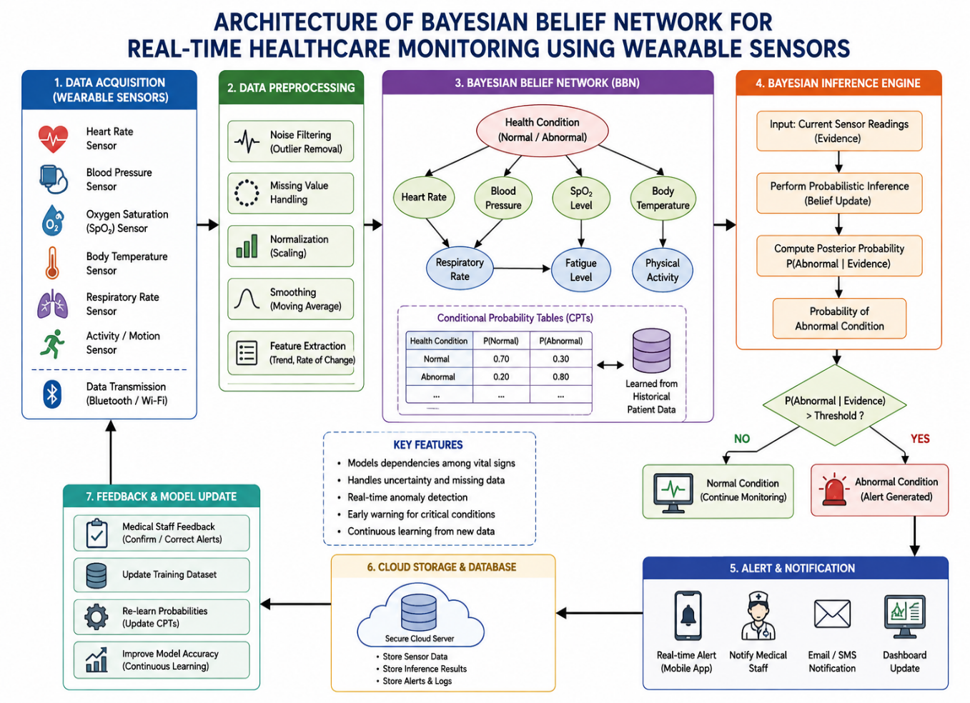
6. Working Methodology:
Step 1: Data Acquisition
Wearable sensors continuously collect physiological information.
The system may collect:
- Heart rate
- Blood pressure
- Oxygen saturation
- Body temperature
- Respiratory rate
- Physical activity
The data is transmitted to the healthcare monitoring system.
Step 2: Data Preprocessing
The collected data may contain noise or missing values.
The preprocessing stage performs:
- Noise removal
- Missing-value handling
- Normalization
- Outlier detection
- Feature extraction
For example, a temporary sensor error that produces an unrealistic heart rate can be detected as an outlier.
Step 3: Construct the Bayesian Belief Network
The Bayesian Belief Network is constructed using physiological variables.
An example network is:
Health Condition
/ | \
/ | \
v v v
Heart Rate Blood Oxygen
Pressure Saturation
| | |
+---------+----------+
|
v
Respiratory Rate
The network represents the relationships among the variables.
Step 4: Learn Probabilities
Historical patient data is used to estimate the probabilities in the network.
For example:
P(Abnormal Condition)
P(Heart Rate | Abnormal Condition)
P(Oxygen Saturation | Abnormal Condition)
P(Blood Pressure | Abnormal Condition)
These probabilities form the basis of the Bayesian model.
Step 5: Receive New Evidence
Suppose a patient's wearable device reports:
- High heart rate.
- Low oxygen saturation.
- Increased respiratory rate.
These observations become evidence for the Bayesian network.
Step 6: Bayesian Inference
The system calculates the posterior probability of an abnormal health condition.
Conceptually:
P(Abnormal Condition | Sensor Data)
The probability is updated whenever new sensor data arrives.
Step 7: Generate Alert
A threshold can be established for the anomaly probability.
For example, if the system calculates:
P(Abnormal Condition | Sensor Data) = 0.82
and the alert threshold is 0.70, the system generates an alert.
If the probability is below the threshold, the system continues normal monitoring.
The threshold shown here is only an illustrative example and should be determined and validated for the actual clinical application.

7. Example of Bayesian Reasoning:
Consider an illustrative patient observation:
Parameter | Observation
Heart Rate | High
Blood Pressure | High
Oxygen Saturation | Low
Temperature | Normal
Respiratory Rate | High
The Bayesian Belief Network receives these observations as evidence.
Suppose, for illustration, that after inference the system estimates:
Health Condition | Probability
Normal | 0.18
Abnormal | 0.82
Since the estimated probability of an abnormal condition is higher, the system generates an alert for further clinical assessment.
This example demonstrates that the system provides a probabilistic indication, rather than claiming that a particular disease has been definitively diagnosed.
8. Handling Sensor Noise:
Sensor noise is one of the major challenges in wearable healthcare systems.
For example, a patient's heart rate may temporarily increase because of physical movement rather than because of a health problem.
The system can handle this using:
- Filtering
- Smoothing
- Outlier detection
- Repeated measurements
- Bayesian probabilistic reasoning
Instead of immediately generating an alert from one abnormal reading, the system can consider other physiological variables and previous observations.
This reduces the possibility of unnecessary alerts.
9. Handling Missing Data:
Sometimes a sensor may temporarily fail to provide a measurement.
For example:
Oxygen Saturation = Missing
A probabilistic model can still use the available information from:
- Heart rate
- Blood pressure
- Temperature
- Respiratory rate
- Previous observations
The system can calculate probabilities using the available evidence rather than automatically rejecting the entire observation.
10. Probability Learning:
Probability learning is an important component of the proposed system.
Historical patient records can be used to estimate:
- Prior probabilities.
- Conditional probabilities.
- Relationships between physiological variables.
- Normal and abnormal patterns.
As more reliable labelled data becomes available, the model can be updated.
For example:
Historical Patient Data
↓
Probability Estimation
↓
Conditional Probability Tables
↓
Bayesian Belief Network
↓
Improved Predictions
Advanced learning approaches such as Maximum Likelihood Estimation or the Expectation-Maximization (EM) algorithm can be used depending on the structure and availability of labelled data.
11. Performance Evaluation:
The system can be evaluated using standard classification metrics.
Accuracy
Accuracy = (TP + TN) / (TP + TN + FP + FN)
It measures the overall percentage of correctly classified cases.
Precision
Precision = TP / (TP + FP)
It measures how many predicted abnormal cases were actually abnormal.
Recall
Recall = TP / (TP + FN)
It measures how many actual abnormal cases were successfully detected.
F1-Score
F1 = 2 × (Precision × Recall) / (Precision + Recall)
F1-score provides a balance between precision and recall.
False Alarm Rate
A healthcare monitoring system should also measure false alarms because excessive false alerts can cause alarm fatigue among medical staff.
Therefore, the system should aim for high sensitivity while maintaining an acceptable false-alarm rate.
12. Advantages:
The proposed Bayesian healthcare monitoring system provides several advantages:
- It supports continuous patient monitoring.
- It can handle uncertain sensor observations.
- It can represent dependencies between physiological variables.
- It can combine multiple sensor readings.
- It can provide probability-based anomaly detection.
- It can generate early warnings.
- It can learn probabilities from historical data.
- It can support healthcare professionals in decision-making.
- It can operate continuously using wearable devices.
13. Limitations and Challenges:
1. Sensor Accuracy
Poor-quality sensors can produce incorrect measurements.
2. Sensor Noise
Movement and incorrect placement can introduce noise.
3. Missing Data
Temporary communication or hardware failures can result in missing observations.
4. False Alarms
The system may generate an alert when the patient is actually normal.
5. Computational Requirements
Real-time Bayesian inference may become computationally expensive for large and complex networks.
6. Training Data
The quality of the Bayesian model depends on the quality and representativeness of historical patient data.
7. Privacy and Security
Healthcare data is sensitive and must be securely collected, stored, and transmitted.
8. Clinical Validation
The system must be properly tested and validated before being used for real clinical decision-making.

14. Real-Time Deployment Challenges:
Real-time healthcare monitoring requires the system to process sensor readings quickly.
The main challenges include:
Continuous Data Stream
Large amounts of sensor data may arrive every second.
Low Latency
Alerts need to be generated quickly when a serious anomaly is detected.
Connectivity
Wireless communication failures can interrupt data transmission.
Battery Consumption
Wearable devices have limited battery capacity.
Scalability
A hospital may need to monitor many patients simultaneously.
Security
Patient data must be protected during collection, transmission, and storage.
15. Analysis:
A Bayesian Belief Network is appropriate for this healthcare application because physiological variables are often related to each other.
For example, an abnormal health condition can influence heart rate, blood pressure, oxygen saturation, and respiratory rate simultaneously. A BBN can represent these relationships using nodes and directed edges.
The system also handles uncertainty effectively. Instead of treating a sensor reading as absolutely correct, Bayesian inference considers the probability of different health states based on the available evidence.
The use of historical data allows the conditional probabilities to be learned and updated. However, the system must be carefully validated because incorrect predictions or excessive false alarms can have serious consequences.

16. Overall System Flow:
The complete process can be summarized as:
Wearable Sensors
↓
Patient Vital Signs
↓
Data Preprocessing
↓
Bayesian Belief Network
↓
Conditional Probability Analysis
↓
Bayesian Inference
↓
Probability of Abnormal Condition
↓
Threshold Evaluation
↓
Normal Monitoring / Alert
↓
Healthcare Professional
↓
Feedback
↓
Model Update
17. Conclusion:
A Bayesian Belief Network-based healthcare monitoring system can continuously analyze physiological data collected from wearable sensors and identify potential abnormalities. The BBN represents conditional dependencies between parameters such as heart rate, blood pressure, oxygen saturation, temperature, and respiratory rate.
Bayesian inference allows the system to handle uncertainty caused by sensor noise, missing values, and incomplete observations. Probability learning from historical patient data helps estimate the prior and conditional probabilities required by the network.
The system can provide real-time alerts and support healthcare professionals in identifying potentially abnormal conditions at an early stage. However, sensor accuracy, false alarms, computational requirements, data privacy, and clinical validation must be carefully considered before real-world deployment.
Overall, the proposed approach demonstrates how Bayesian Belief Networks and probability learning can be applied to intelligent real-time healthcare monitoring under uncertainty.

RUBRICS FOR CALCULATION

Criteria | Weightage | Level 4 –  Exemplary (5 Marks) | Level 3 –  Proficient (4 Marks) | Level 2 –  Developing (2–3 Marks) | Level 1 –  Beginning (0–1 Mark)
Conceptual Understanding | 30 | Demonstrates clear and complete understanding of the concept | Good understanding with minor gaps | Basic understanding with some  misconceptions | Poor or incorrect understanding
Accuracy of Answer | 20 | Completely correct answer with no errors | Mostly correct with minor errors | Partially correct with noticeable errors | Incorrect or irrelevant answer
Application of Knowledge | 20 | Correctly applies concepts to solve the question/problem | Applies concepts with minor mistakes | Limited or partially correct application | No or incorrect application
Completeness of Response | 15 | Covers all required parts of the question | Covers most parts with minor omissions | Covers only some parts | Incomplete or missing response
Clarity & Presentation | 15 | Clear, concise, and well-organized answer | Understandable with minor issues | Somewhat unclear or poorly structured | Difficult to understand

